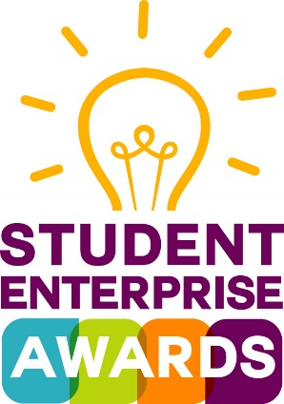

GMIT STUDENT ENTERPRISE AWARDS 2016 ENTRY FORM
(Due to requests the closing date has been extended to January 29th 2016 at 5pm)

PLEASE COMPLETE THE ENTRY FORM, INCLUDE A LINK TO YOUR
YOUTUBE VIDEO AND ONCE COMPLETED, EMAIL TO

innovationhubmayo@gmit.ie

PLEASE NOTE THAT WE CANNOT ACCEPT SEPARATE VIDEOS FILES

Entries must be typed. The answer boxes can be resized if you need more space.

Personal Details

For group entries please put in the contact details of the team leader & group name

First Name |  | Surname
Address |  | Phone Number
Date of Birth |  | Email

Group Name

Names of other group members (if any)

Student ID No. & Campus

Programme & Year

Link to your video*

* To allow the panel to view your video, you must upload the video to YouTube

and provide us with a link to the uploaded content.

{Please choose the privacy option unlisted. Making a video unlisted means that anyone who has the link to the video can view it. Your unlisted videos won’t appear to others who visit the Videos tab of your channel page and shouldn't show up in YouTube's search results unless someone adds your unlisted video to a public playlist. To share an unlisted video, just share the link with the people who you’d like to have access to it, and they’ll be able to see it. Your YouTube account needs to be in good standing to be able to create unlisted videos}

Further details are provided on the YouTube website.

Title and description of your idea (approx. 100 words)

Title:

Description:

Have you read, understood and do you accept the terms and conditions (see below) of the GMIT Student Enterprise Awards?

Yes No Date: _________ Signature: __________________

Student Enterprise Awards Terms and Conditions

- Entries can be groups (max 4 people) or individuals.

- People can submit more than one application

- It is recommended that you keep a copy of the signed completed entry form and of your video.

- Finalists are wholly responsible for the development of their project

- The project must be the students/teams idea only. Full ownership of the project must reside with the students/teams submitting the application to the GMIT Student Enterprise Awards.

- If one or two of the team decide to pursue with the business concept, they must do so in full agreement with the remainder of their team.

Data Protection and Privacy Statement

All information received will be treated in confidence and in line with the GMIT Data Protection and Privacy Statement

For further enquiries call Annemarie Cahill GMIT Innovation Hubs (Mayo) on

Tel: +353 (0)94 9043198 or email innovationhubmayo@gmit.ie

#ideasGMIT

