Caomhan Conaghan
Caomhan Conaghan is a PhD researcher and Research and Innovation Strategic Endowment (RISE) Scholarship recipient in Atlantic Technological University (ATU), Galway. His work focuses on concussion awareness and the development of research-based concussion education interventions. He has recently spent time delivering concussion workshops to over 600 secondary school students throughout Connacht and Munster.
Prior to his time in ATU, Caomhan obtained a first-class honours degree in Sports Science with Exercise Physiology in Technological University of the Shannon Midlands (formerly Athlone Institute of Technology). While studying there, he contributed to projects assessing Reactive Strength Index in athletes and Fundamental Movement Skills in adolescents.
Caomhan also spent time working in Slovenia’s largest research institute, The Jožef Stefan Institute, who employ over 400 PhD scientists. During this time, he worked with a team of physiologists and architects on project HEAT-SHIELD, which was addressing the negative impact of increased workplace heat stress on health and productivity in European industries.
Since beginning his research in ATU, Caomhan has published two studies on concussion education initiatives, with several others currently under preparation.

LinkedIn: linkedin.com/in/caomhan-conaghan-2a83b9141
Email: CAOMHAN.CONAGHAN@research.gmit.ie

Ayrton Walshe
Ayrton Walshe is a graduate from ATU, Galway’s Sport & Exercise Science program and a ATU RISE Research Masters Scholar. He has a keen interest in education, athlete welfare, and mental health, and has two publications in the area of Sports Nutrition.
Ayrton's goal is to trouble shoot the female concussion landscape in Ireland and make develop effective strategies to ensure athletes, coaches, and allied healthcare professionals are supported in the pursuit of best practice when it comes to concussion treatment.
Ayrton is a NSCA Certified Strength & Conditioning Coach, an ACSM Certified Personal Trainer and has experience as a Sport Scientist with multiple NGBs across a variety of sports.
He is currently in his first year of his Research Masters and has intentions to pursue a full PhD in the coming years.

LinkedIn: linkedin.com/in/ayrton-walshe
Email: AYRTON.WALSHE@research.gmit.ie
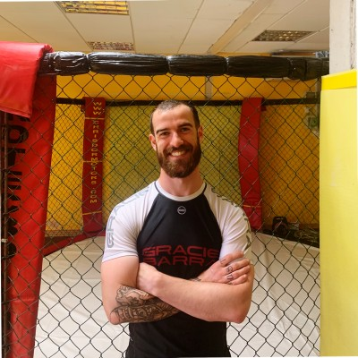

Georgia Keys

Georgia Keys is a current PhD researcher investigating workload monitoring within field-based sports and the development of a predictive analytics model for injury risk identification and prediction.
Georgia completed her BSc. In Athletic Therapy and Training in Dublin City University (DCU) in 2021.
As a certified athletic therapist, she has experience working in both an elite and amateur sporting environment providing pitch side management, injury identification, rehabilitation and injury prevention within the GAA, LOI and Rugby.

Georgia has a keen interest in the development concussion risk reduction measures within field-based sports at both an elite and amateur level. She hopes that within her research she can increase accuracy with regards to injury risk identification and increase appropriate training prescription among field-based sports.

LinkedIn:
Emma Finnegan

Emma Finnegan is a current MSc researcher investigating the 'Role of Nutrition in Concussion Recovery and Management' under the supervision of Dr Lisa Ryan and Ed Daly. Emma was awarded a postgraduate scholarship from Atlantic Technological University (ATU), Galway, in January 2021 and completed her BSc. Degree in Health Sciences and Nutrition in Technological University of the Shannon (TUS) in 2016 and, NEFPC qualified. As a nutritionist, she has experience working over eight years of experience in the health and nutrition sector. Previously, Emma worked at University College Dublin (UCD) on the Childhood Obesity Surveillance Initiative (COSI) and Ulster University on Vitamin D research. She also worked with Brian Keane Fitness as Head of Operations and head nutrition coach.

Currently, Emma has over three years of experience working as a research assistant at ATU, Galway City on a number of sport and nutrition-specific Erasmus+ projects and has extensive experience in project coordination, communications and execution.

Emma has a keen interest in the role nutrition and movement play in health, their role in mental health, and essential support during injury recovery. She hopes her research will highlight the vital role nutrition plays in following an acute injury, specifically in brain recovery following a mild traumatic brain injury—an invisible injury where nutrition consideration is often overlooked.

LinkedIn: linkedin.com/in/emma-finnegan-885732147
Twitter: @irish_smilers
Email: emma.finnegan@atu.ie

Damien Costello
Damien Costello is a lecturer in software development with the Department of Computer Science & Applied Physics in the Atlantic Technological University, Galway City. Over the past twenty years, he has lectured in many areas including mobile applications, AI, embedded software, cross-platform development and gesture-based user interface development.
Throughout his academic career, he has collaborated with industry partners on a range of applied projects. These have included prototyping and proof-of-concept software for conflict resolution training using a virtual environment, concussion testing, biomechanical modelling, data presentation in an augmented environment and biometric data capture.
Damien’s research interests include the use of technology in sport for assessment, improvement and education. He is currently a PhD researcher focusing on concussion tracking and reduction strategies in the amateur sport.
LinkedIn: linkedin.com/in/damienc
Email: Damien.Costello@atu.ie
: 