Research Project Title: Exploitation of Small Diameter Alder (Exploitation of the working properties and utilisation of small-diameter Irish-grown alder (Alnus glutinosa)
Research Student: Colin Marren
Research Supervisors: Mr Sean Garvey, Mr Kevin Maye & Mr Dermot O’Donovan.

Background
In Ireland approximately 95% of hardwoods used in the furniture and woodworking industries is imported. There is however a significant amount of broadleaf plantations from which small-diameter thinnings can be harvested. Much of that material is currently directed to the firewood market, negating any added-value potential which could be realised through markets for better quality material. There is potential to reduce reliance on imported hardwoods through the use of advances made in the processing of small diameter hardwood logs and in the development of innovative uses for small-sized sawn hardwoods.

Project
This Teagasc-funded project, partnered with GMIT Letterfrack, will establish the characteristics, properties and utilisation potential of small-diameter (20 – 30 cm) Irish-grown alder (Alnus glutinosa) with the aim of supporting woodland owners in developing new markets for timber and small enterprises wishing to use Irish timber. It is anticipated that the findings may have wider application to other species and to larger diameter material and will also close the knowledge gap existing between woodland owners and their potential markets. In order to establish what other markets exist for this material, opportunities to add-value and establish new utilisation potential of alder will be explored by establishing the working and finishing properties and investigating innovative uses.
The research project will establish the working properties of alder in relation to:
• Conversion
• Seasoning / kiln drying
• Processing (planing, sanding, etc.)
• Nailing /Screwing
• Bonding
• Finishing

Methodology
In order to establish the working properties of juvenile alder the following experimental design is being employed.
• Conversion. Using different sawing methods, compare the yield of useable timber produced.
• Seasoning / Kiln drying. Comparing 3 different drying methods:
1) air-dried followed by kiln drying using industry standard Schedule J (Control treatment);
2) air-dried followed by kiln drying using a novel schedule; and
3) green timber kiln dried using industry standard Schedule J.
These three drying methods will undergo mechanical testing in line with the BS EN 373 standard to reveal what level of degrade, if any, has occurred from the different drying methods.
• Processing. Sanding, planing, drilling and CNC machining/milling tests will be conducted and evaluated according to the ASTM D1666 document.
• Nailing / screwing. Nail and screw withdrawal tests will be conducted with reference to the NSAI EN 1382:2016 document. This will produce screw and nail holding capabilities of alder. Cleavage strength tests from BS EN 373 will give an indication of how prone the wood is to splitting when being nailed or screwed.
• Bonding. Tensile shear strength of bonded samples will be tested with reference to the BS EN 205 document. Wettability tests will also be conducted which will give an indication of how adhesive will penetrate into the alder past the surface and bond with the wood.
• Finishing. Taking wettability measurements will give an indication to how the wood is likely to react to finishing materials. Pull off tests will be conducted according to the ASTM D4541-17 document. This will give the strength of adhesion between alder and the finishing material.

Cognisant of the results from these experiments, an informed decision will be made regarding potential markets and/or products suitable for juvenile alder. Depending on the outcome of these experiments and what markets or products may be suitable for juvenile alder, prototypes, surveys, market research or other areas will be explored, tested and validated.

Outcomes
Outcomes will include developing product prototypes and resources designed on the basis of maximising the utilisation potential of the species.
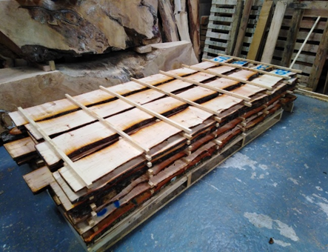
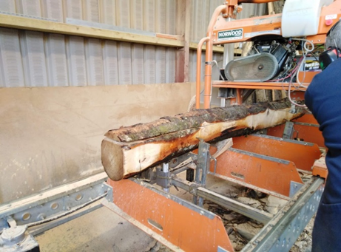
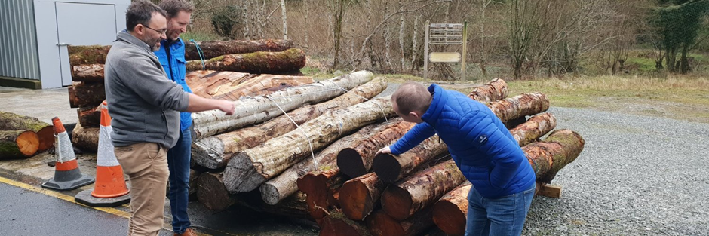
Figure 3. Planks from small diameter alder logs, stacked and stickered ready for drying.
Figure 2. A small diameter alder log being sawn on the GMIT Letterfrack mill.
Figure 1 Inspecting some small diameter alder logs at GMIT Letterfrack. L to R Dr Ian Short (Teagasc), Sean Garvey (GMIT Letterfrack), Colin Marren (Walsh Scholar)

Project team
Dr Ian Short, Teagasc
Dermot O’Donovan, eWIL Project Manager, GMIT Letterfrack. Dermot.ODonovan@gmit.ie
Sean Garvey, National Centre of Excellence for Furniture Design and Wood Technology, GMIT Letterfrack. Sean.Garvey@gmit.ie
Kevin Maye, National Centre of Excellence for Furniture Design and Wood Technology, GMIT Letterfrack. Kevin.Maye@gmit.ie
M.Sc. Walsh Scholar Colin Marren, National Centre of Excellence of Furniture Design and Wood Technology, GMIT Letterfrack. Colin.Marren@Research.gmit.ie

Publications
Spazzi, J., Garvey, S. and Short, I. 2019. Developing new hardwood markets for Irish timber. Irish Forestry 76 (1&2): 60-72.

References
- ASTM D1666-17, Standard Test Methods for Conducting Machining Tests of Wood and Wood-Base Panel Materials, ASTM International, West Conshohocken, PA, 2017, www.astm.org
- ASTM D4541-17, Standard Test Method for Pull-Off Strength of Coatings Using Portable Adhesion Testers, ASTM International, West Conshohocken, PA, 2017, www.astm.org
- BS EN 205:2003, Adhesives - Wood adhesives for non-structural applications - Determination of tensile shear strength of lap joints
- BS EN 373:1957, Methods of Testing Small Clear Specimens of Timber. (1999 imprint)
- NSAI EN 1382:2016, Timber Structures – Test Methods – Withdrawal Capacity of Timber Fasteners.

