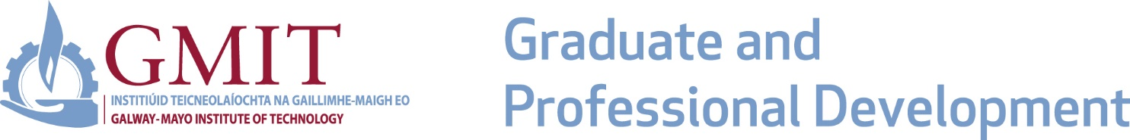

Application Form: Higher Diploma in Civil Engineering

Application Checklist:
- Please complete the application form in full paying particular attention to Data Protection Requirements on Page 4. Once the Application is completed, please email it to gpd@gmit.ie

- Please include examination transcripts certified by college authorities where specified as a course entry requirement.

- Include confirmation from employer where a course is funded through CPD.

PLEASE NOTE:
- It is the applicant’s responsibility to ensure that all the above documents reach the Centre for Graduate and Professional Development before 31st August for entry to programmes commencing in September.

- Tuition fees are payable upon course commencement. Details of tuition fees are available from the Centre for Graduate and Professional Development.

- The Institute reserves the right to cancel, suspend or modify courses at any time.

- Further information is available from the Centre for Graduate and Professional Development, GMIT, Dublin Rd. Galway:

Tel: Mary Russell 091 742145 / Peter Butler 091 742328 / Emily King 091 742418

Email: mary.russell@gmit.ie

Web: www.gmit.ie/lifelong-learning

PERSONAL DETAILS

Surname First Name
Address for Correspondence

Title (Mr\Mrs\Ms) Mobile No.

Date of Birth Email
Place of Birth Nationality

Male Female PPSN:

PREVIOUS QUALIFICATIONS

Award Title

Awarding Body

College Attended or
Currently Attending

Date From Date To

WORK EXPERIENCE
Please give details of any relevant work experience

ANY FURTHER INFORMATION RELEVANT TO THE APPLICATION
Applicants should make themselves aware of any special entry requirements for a course

EMPLOYER CONTACT DETAILS

Employer Name
Contact Person

Email

Mobile No.

Company Address

PAYMENT DETAILS

Payment by credit card, bank draft, cheque is accepted. Please note you will be contacted upon course commencement for payment.
For further information, please contact:
Mary Russell, Graduate and Professional Development, GMIT, Dublin Rd. Galway
Tel: 091 742145
Email: gpd@gmit.ie

DECLARATION
I declare that the information I have submitted is true and correct. Should my application be successful, I agree to abide by the Rules, Regulations, Policies and Procedures of GMIT as set out in the Code of Student Conduct and the relevant sections of the GMIT website.

Signed Date

Note: Applicant and employer will be required to sign tri-partite agreement with GMIT prior to registration on the programme.

DATA PROTECTION

As a student of GMIT, I understand that my personal data will be processed by the Institute. Information on how your data is processed is available in our Student Privacy Statement.

I confirm that I have read and understood the GMIT Student Privacy Statement and am agreeable to my personal data being processed in accordance with that notice.

If you have any queries in relation to the processing of your personal data by GMIT, please contact the Data Protection Officer at dpo@gmit.ie

Please note that your data will be shared with the Higher Education Authority (HEA) for funding allocation, statistical analysis and policy formulation purposes. The data shared includes personal data such as name, address, Eircode, PPSN, grant status and CAO data. By continuing with your registration, you are agreeing to your data being shared with the HEA. Full details of what data is shared and how this data is used are contained in the Student Privacy Statement referenced above. If you wish to object to the processing of your personal data in this manner, or if you have any queries in relation to the processing of your personal data by the HEA generally, please contact the HEA Data Protection Officer at dataprotection@hea.ie

